Sales Dashboard Report

This report is about the dashboards made with the help of Microsoft Power BI software (ver. 2.1).

In the following document, the main focus is to analyze the data given in the sample dataset

I have solved all the above queries by using multiple dashboards.

The following four dashboards I have made are:

* Sales Dashboard
* Profit Dashboard
* Order Details based on priority
* Manager Analysis

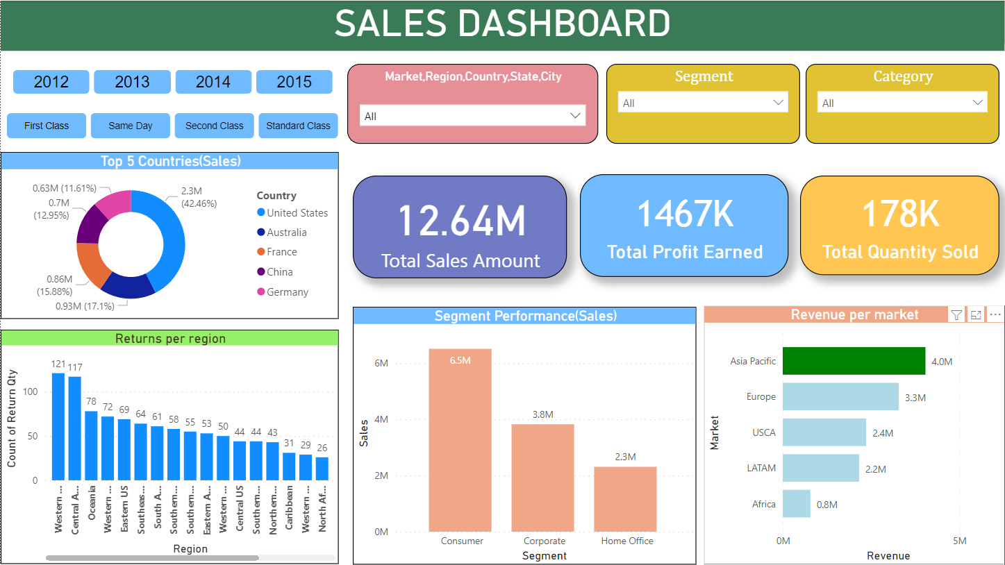Sales Dashboard

This dashboard consists of sales data along with product return data.

The following features are present in this dashboard:

* There are two slicers (year & ship mode) in the dashboard, which will help us to show selected data.

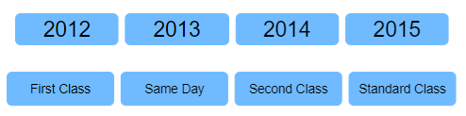

* A drop-down slicer from where we can select market, region, country, state and city to show corresponding data.

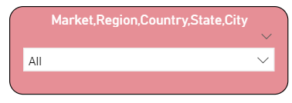

* There are also product **segment** and product **category** (& **sub-category**) slicers to view **sales** related to a particular segment and category.

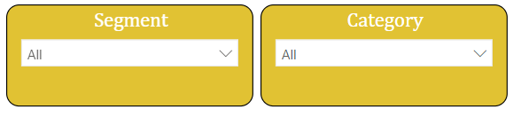

* A donut chart representing the **top 5 countries in terms of sales**.

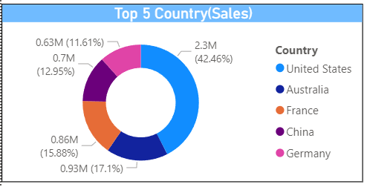

* The **highest revenue generating market,** i.e. the Asia Pacific, is highlighted as green color in the ‘Revenue per market’ bar chart.

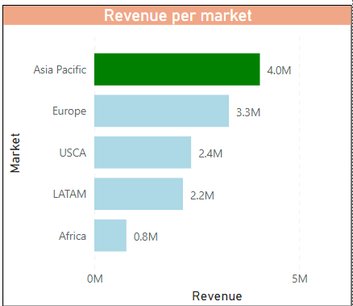

* There is a column chart named ‘Returns per region’, which portrays the number of product returns along regions. Here, we can see that the region ‘Western Europe’ has the **highest number of products returns,** i.e. 121.

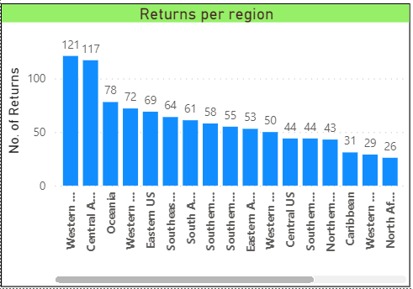

* The chart ‘Segment Performance (Sales)’ tells us which segment has how many sales amounts. From this chart we can see that the ‘Consumer’ segment has the highest sales so, it is the **best performing segment**.

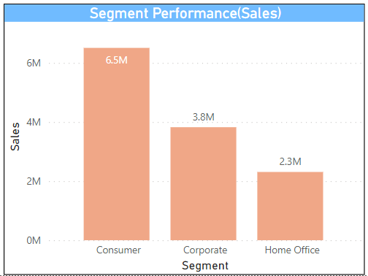

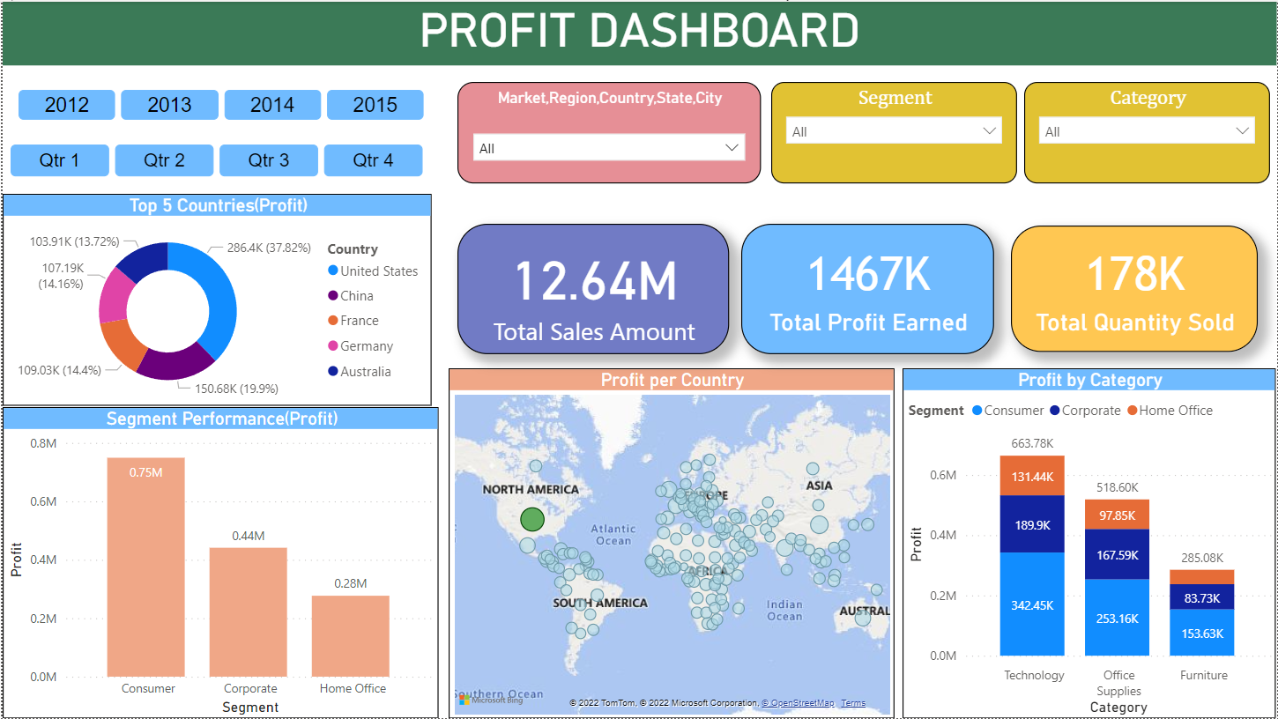Profit Dashboard

The profit dashboard highlights the comparative visualisation of profit data with many other aspects.

The features present in the above dashboard are as follows:

* There are two slicers (year & quarter) in the dashboard, which will help us show profit earned according to selected year and quarter.

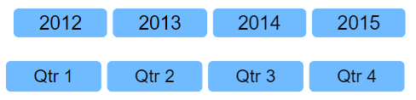

* Like the previous dashboard, this also features the market hierarchy, segment and category hierarchy slicer.

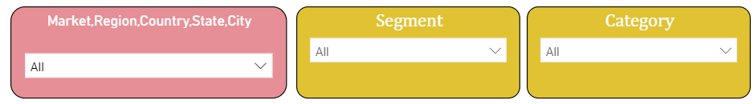

* **Top 5 countries** with respect to **profit** earned is represented as the donut chart.

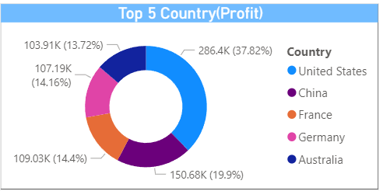

* There is a ‘Segment Performance (Profit)’ chart showing which segment books how much profit.

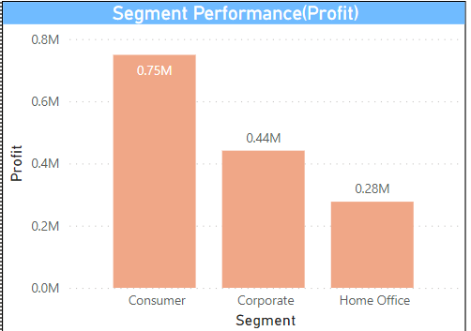

* The bubble size in the map shows us how much profit is earned from which country. Also, the deep/dark green bubble indicates the highest profitable country.

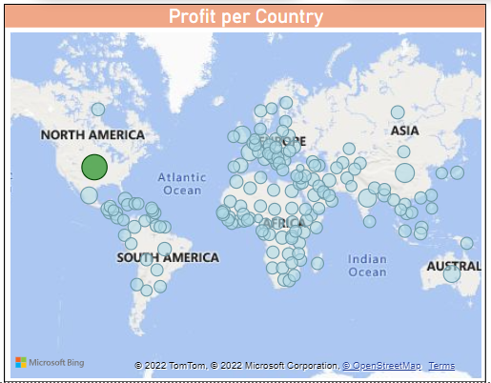

* The stacked column chart ‘Profit by Category’ shows us how much profit is earned by which product Category and Segment.

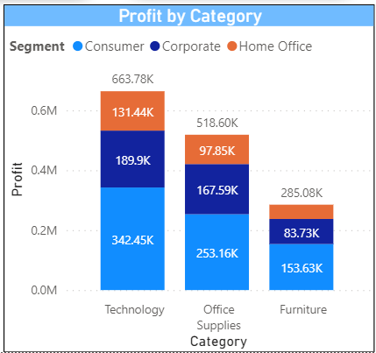

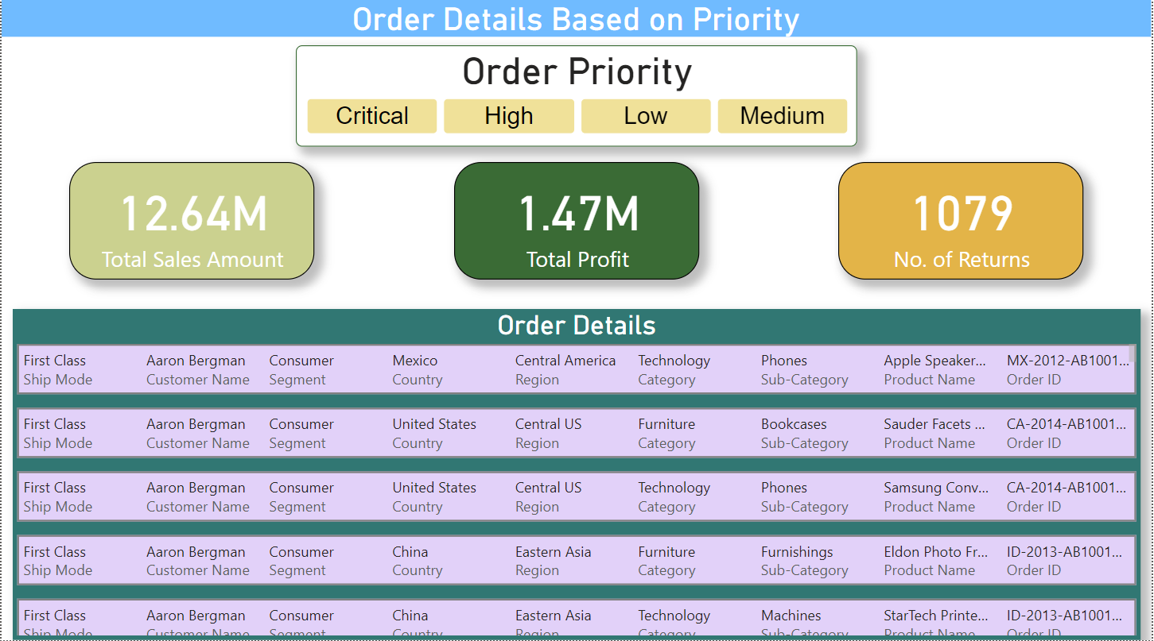Order Details (Priority)

This visualisation shows us the **order details based on priority**. In the slicer ‘Order Priority’, we can select any option and view corresponding order details, total sales, profit and returns.

Example: If we select order priority as ‘Medium’, we get the following output

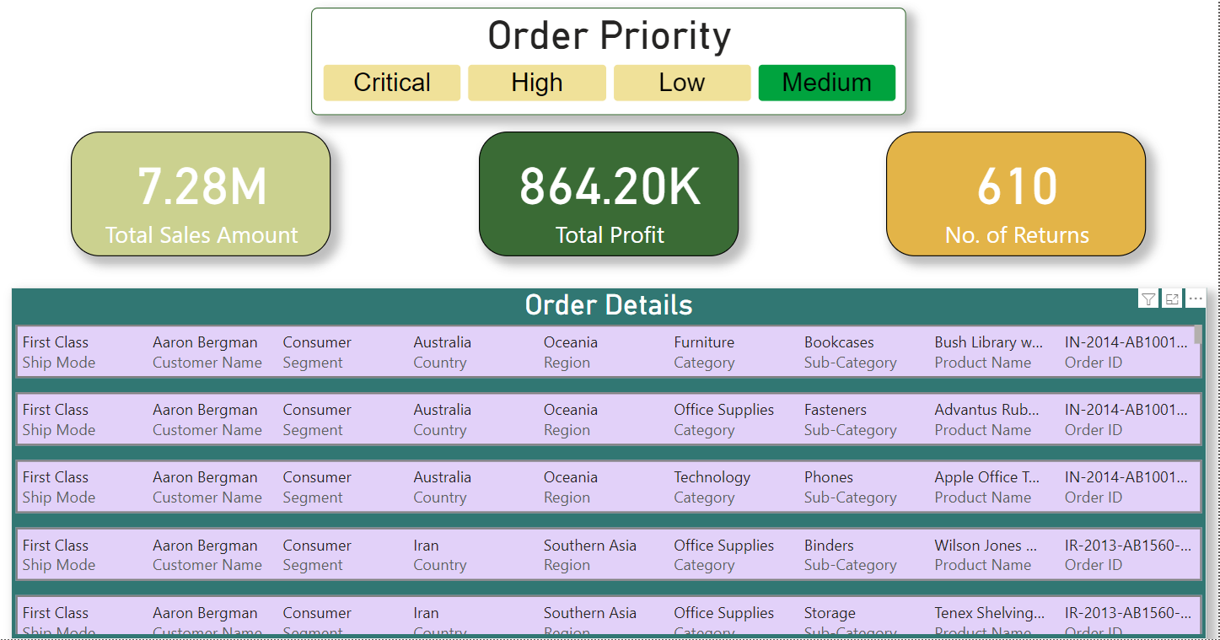

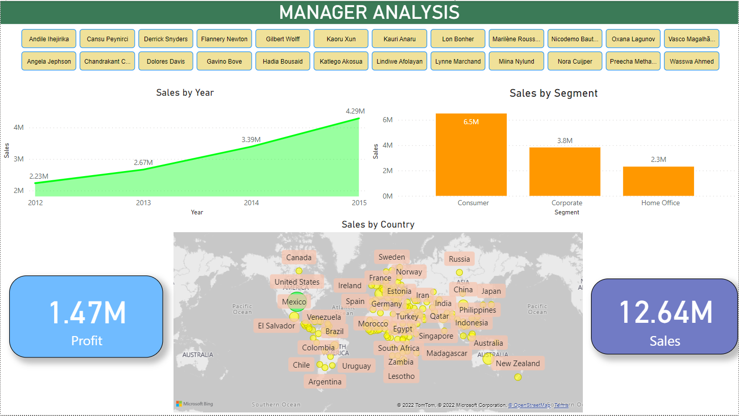Manager Analysis

This dashboard will help us to analyse the Manager according to his performance.

The following features are present in this dashboard:

* We can select a manager and see their respective performance. For example. –

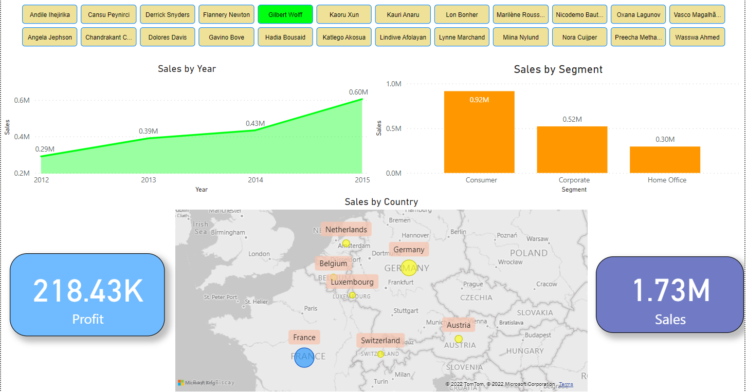

The result after selecting a manager named ‘Gilbert Wolff’

* The area chart shows the number of sales per year of the selected manager.

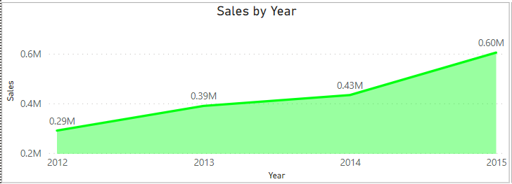

* There is a column chart ‘Sales by Segment’, which shows the sales with respect to the product segment of the selected manager.

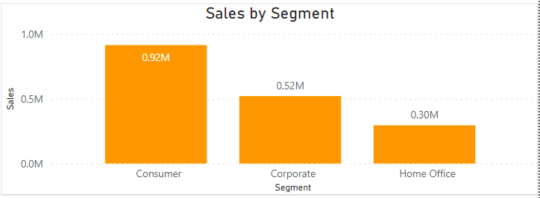

* The world map indicates the sales of selected managers as per the countries they manage.

